Images of Greyson Playing Soccer- October 28, 2017

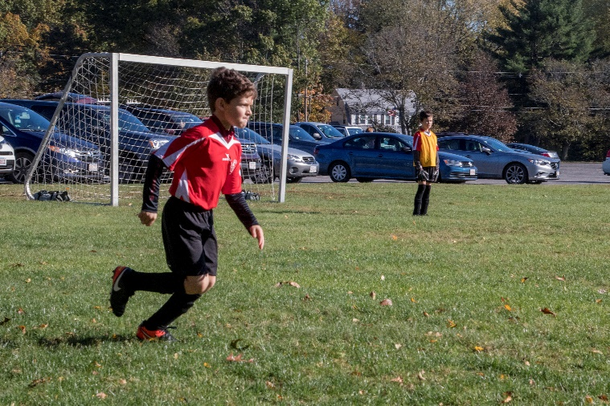On Saturday, the 28th, we traveled down to Littleton, MA, to see grandson Greyson play another game of organized soccer. Grey has been involved in the game for several years and is getting his techniques nicely polished. This year he is in the 3-4 grade Stow team competing with various area town teams.

And for the photos, click [Greyson – Soccer](https://photos.app.goo.gl/6yiZPrdGemxdTQlf1).